GardianPro User Manual

**Login GardianPro**

Input the provided user name and password to enter GardianPro system

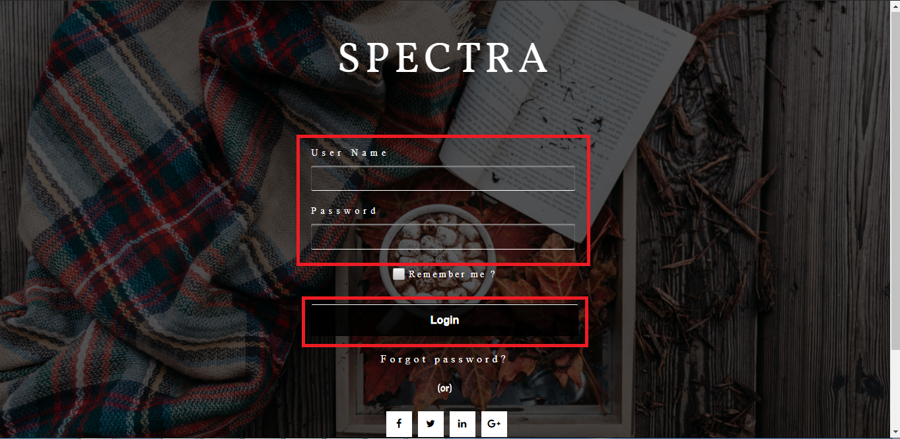

**Create a new Terminal Group Record**

After login, it enters the Main page. To create a new terminal Group record, press “TerminalGroup”

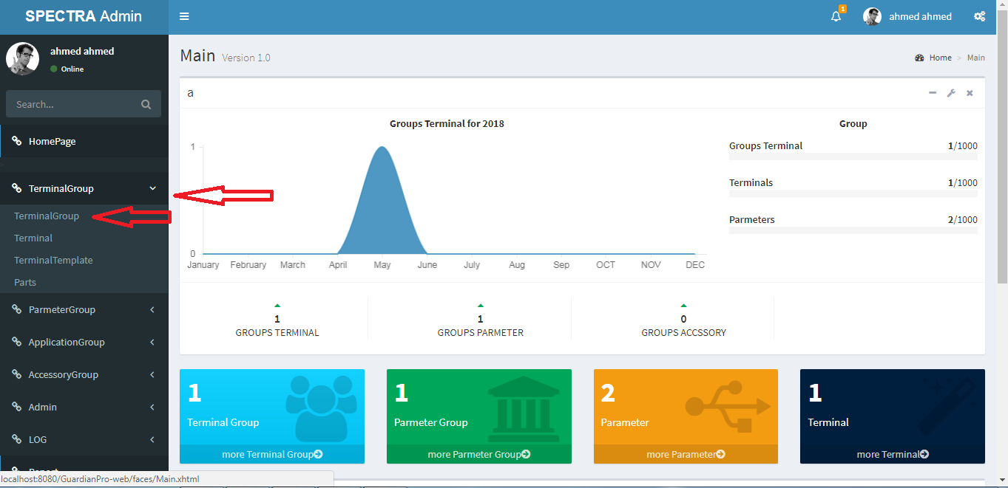

Then the following page will appear:

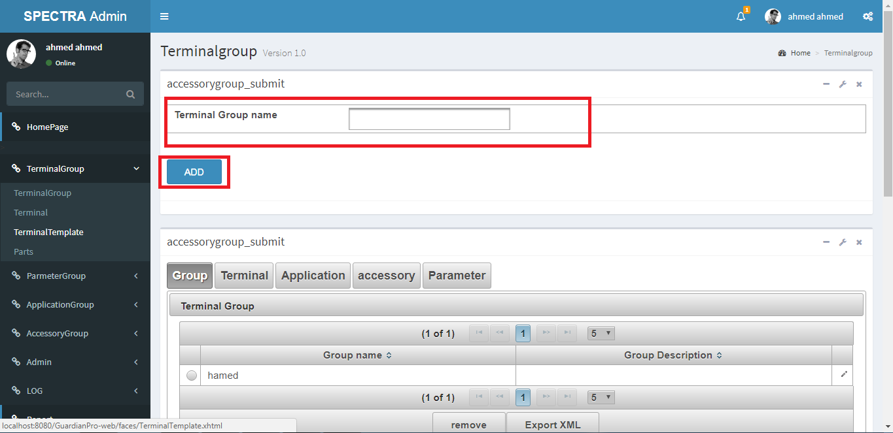

After enter Terminal Group Name, press “Add” button on the bottom to save.

**Create a new Terminal Record**

To create a new terminal record, press “Terminal”

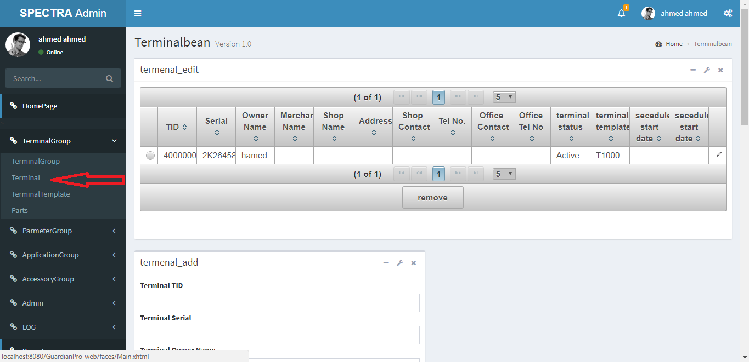

Then the following page will appear:

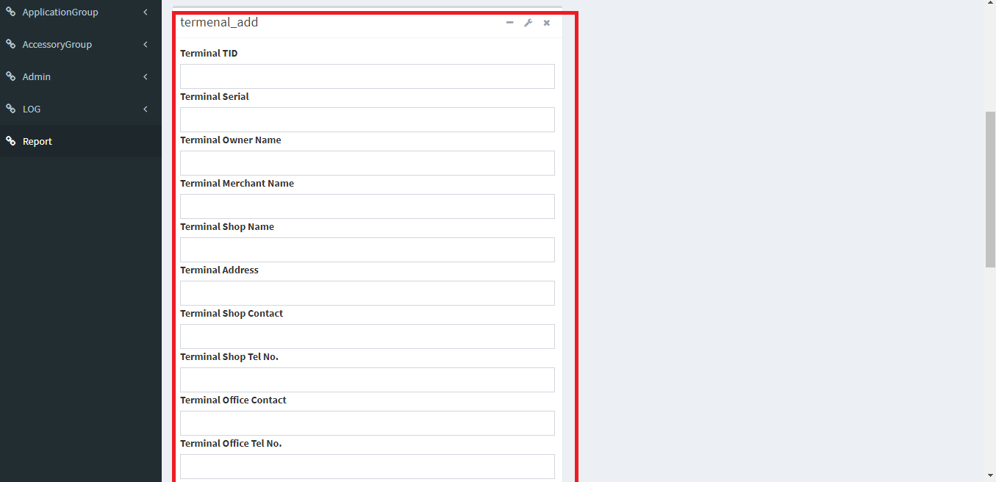

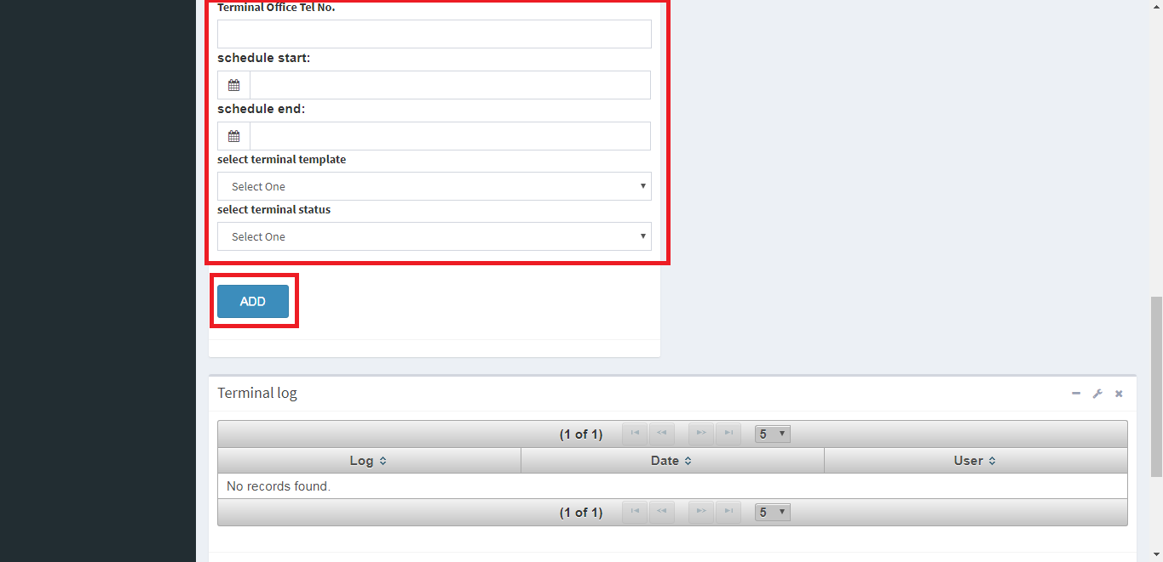

After finish editing all the parameters, press “Add” button on the bottom to save.

To remove existing terminal record.

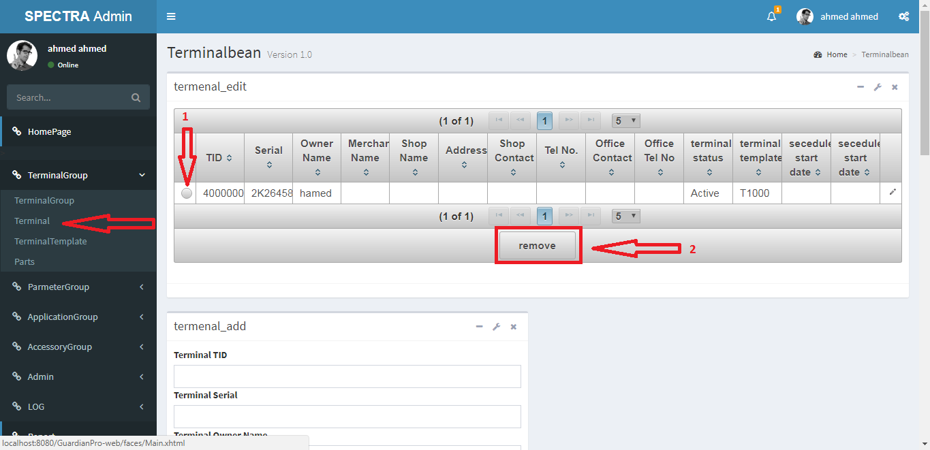

After choose the terminal, press “remove” button on the bottom to remove.

**Create a new Terminal Template Record**

To create a new terminal record, press “TerminalTemplate”

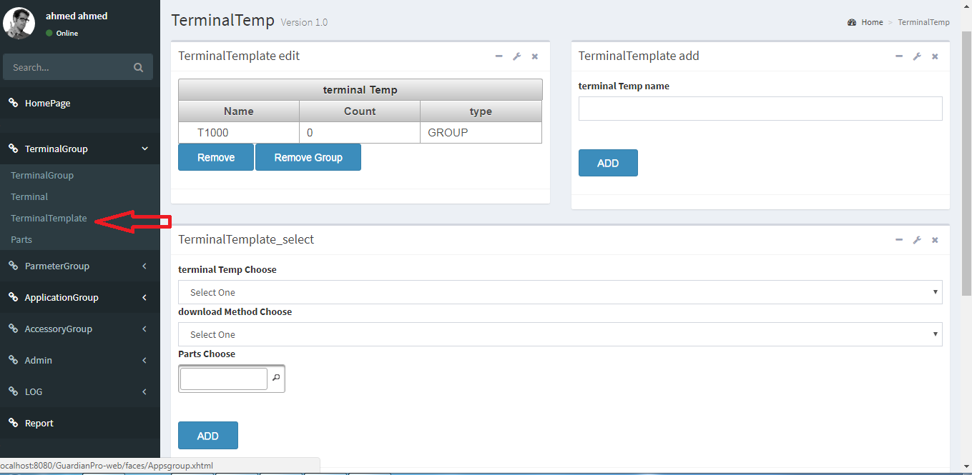

Then the following page will appear:

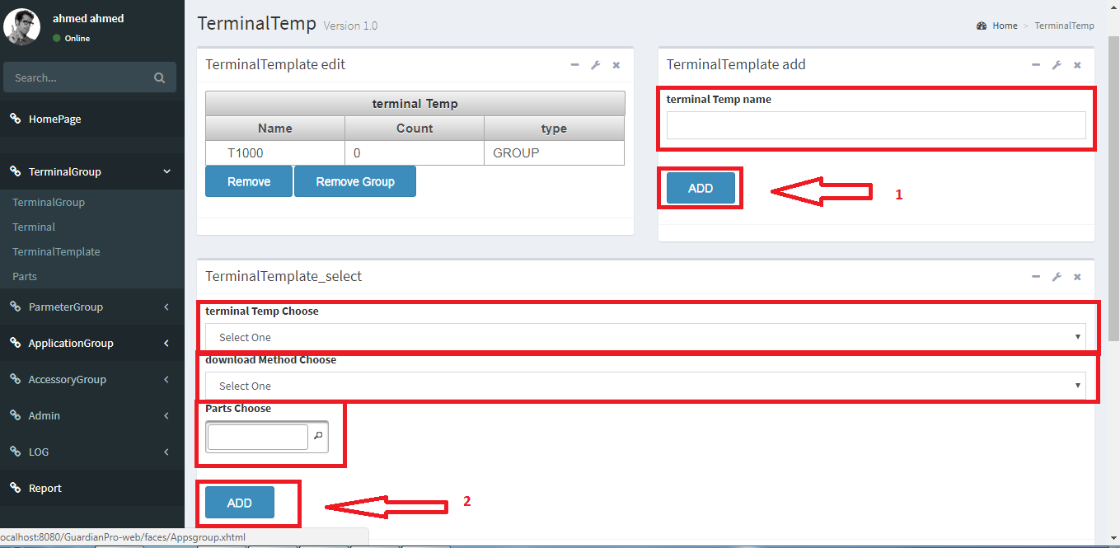

After enter Terminal Template Name, press “Add” button on the bottom to save Template Name, then choose terminal template name, download method and parts then press “Add” button on the bottom to save Terminal Template.

To remove existing terminal Template record.

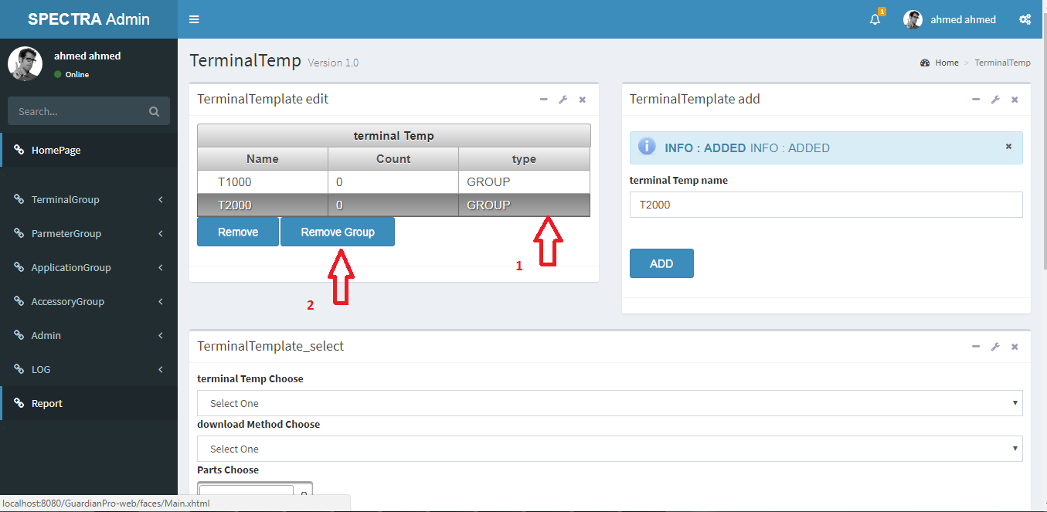

After choose the terminal Template, press “remove Group” button on the bottom to remove.

**Create a new Parts Record**

To create a new Parts, press “Parts”

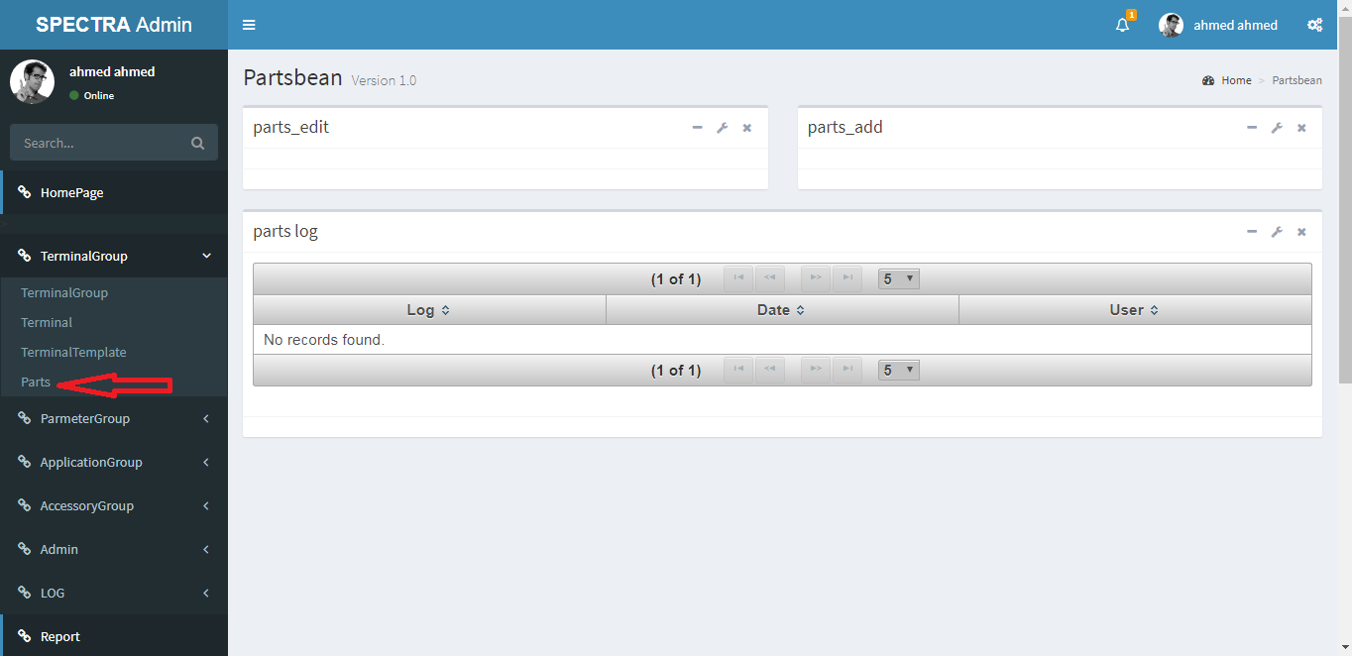

Then the following page will appear:

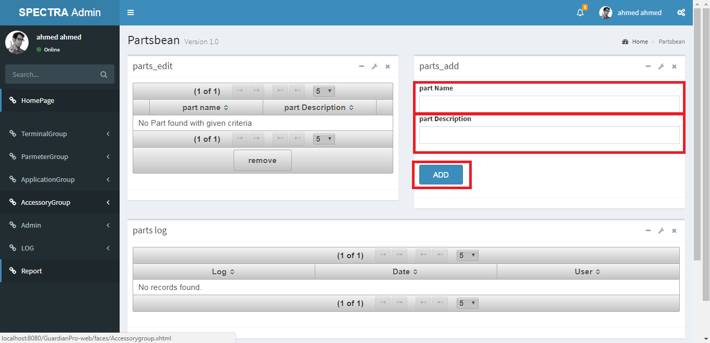

After enter Part Name and Description, press “Add” button on the bottom to save.

To remove existing Part record.

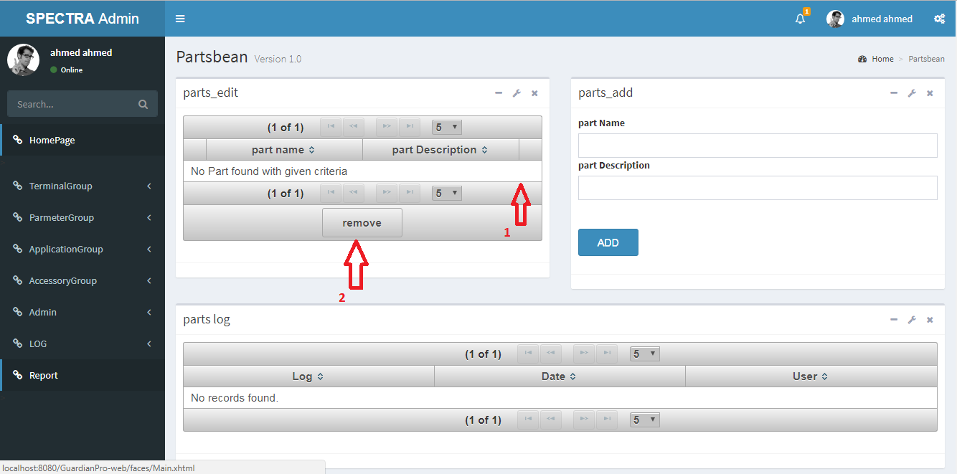

After choose the part, press “remove” button on the bottom to remove.

**Create a new Parameter Group Record**

To create a new Parameter Group record, press “ParameterGroup”

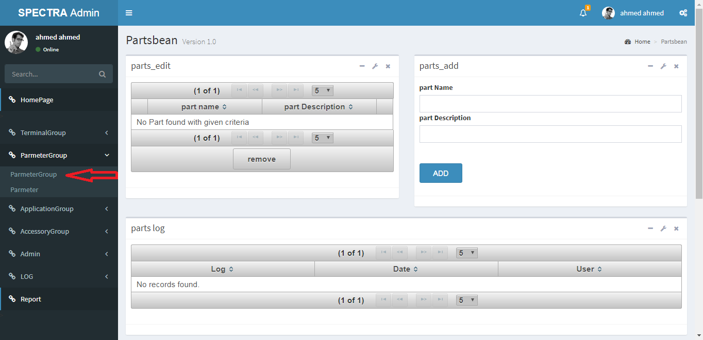

Then the following page will appear:

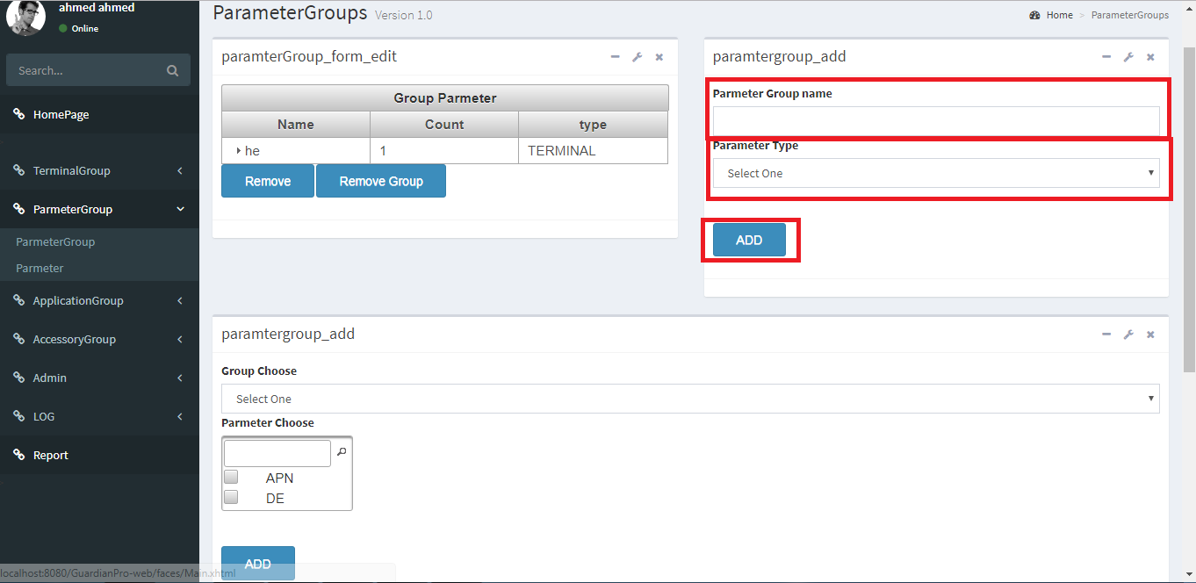

After enter Parameter Group Name and choose Parameter Type, press “Add” button on the bottom to save.

To attach Parameters to parameter Group.

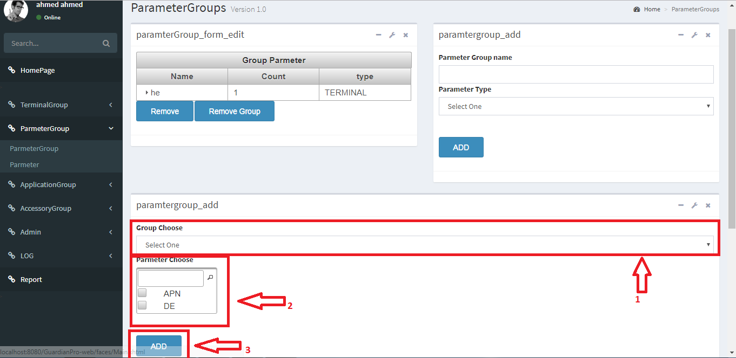

After choose Parameter Group, attach parameter to this group then press “Add” button on the bottom to save.

To remove existing Parameter Group record.

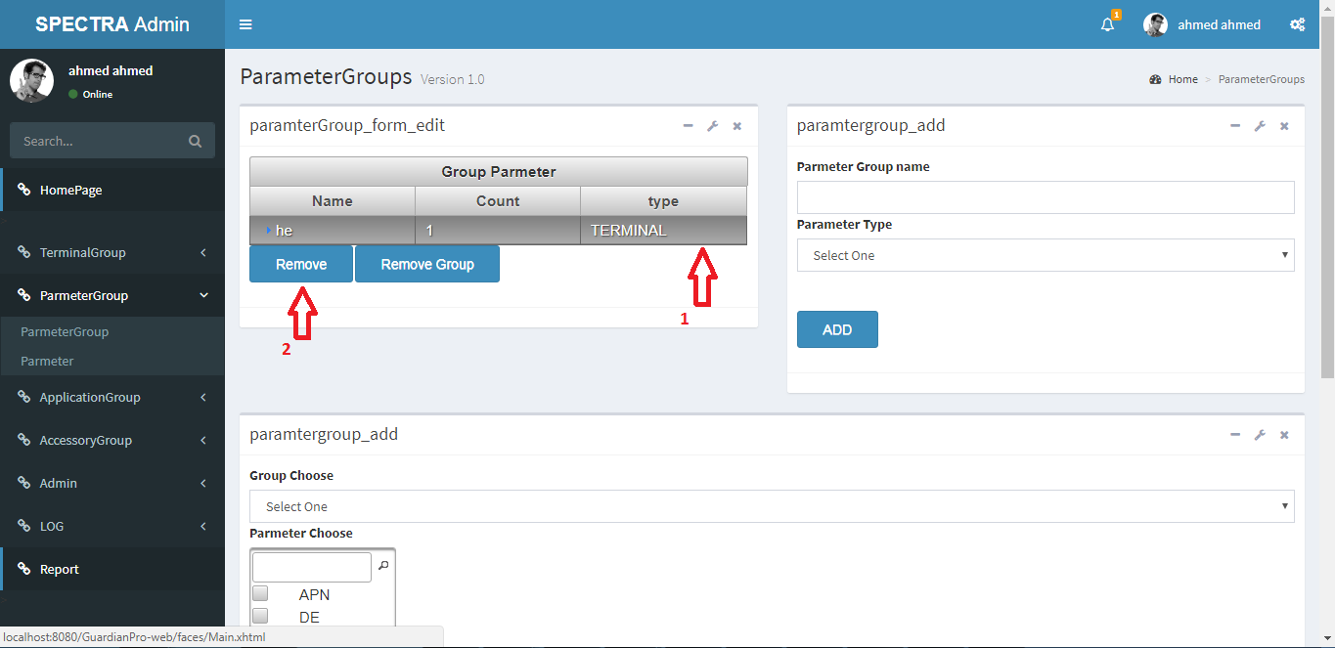

**Create a new Parameter Record**

To create a new Parameter record, press “Parameter”

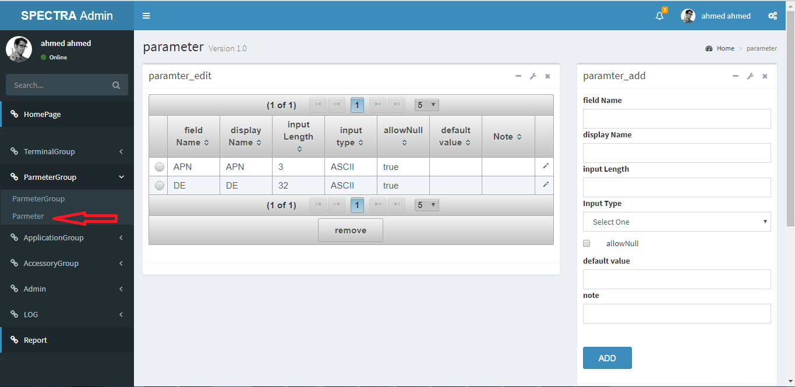

Then the following page will appear:

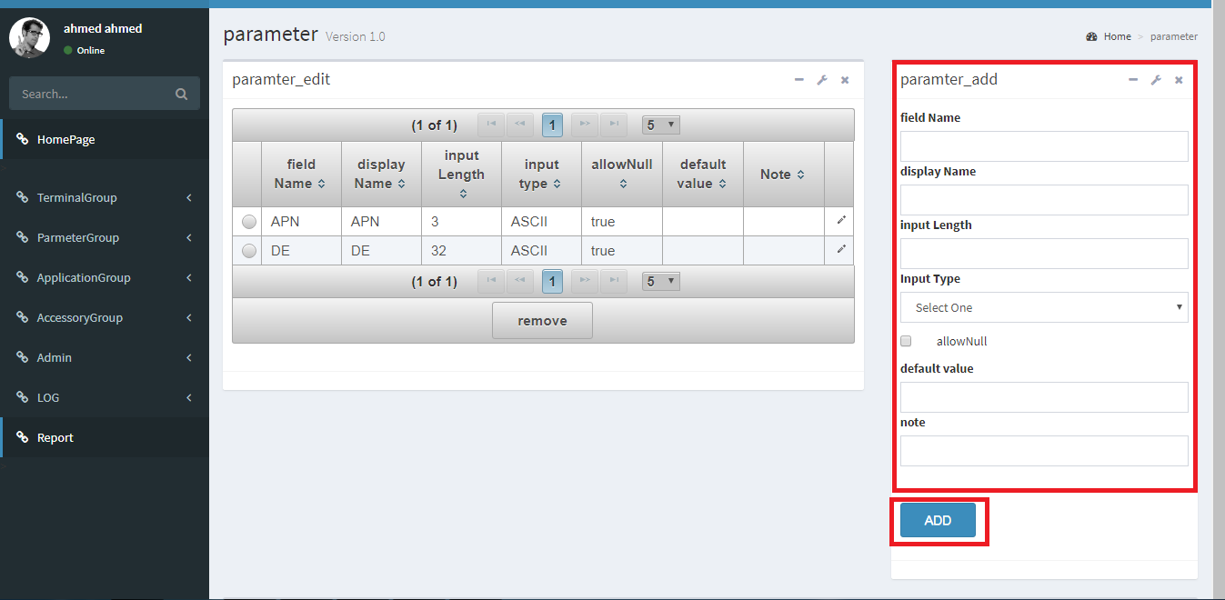

After finish editing all the parameters, press “Add” button on the bottom to save.

To remove existing Parameter record.

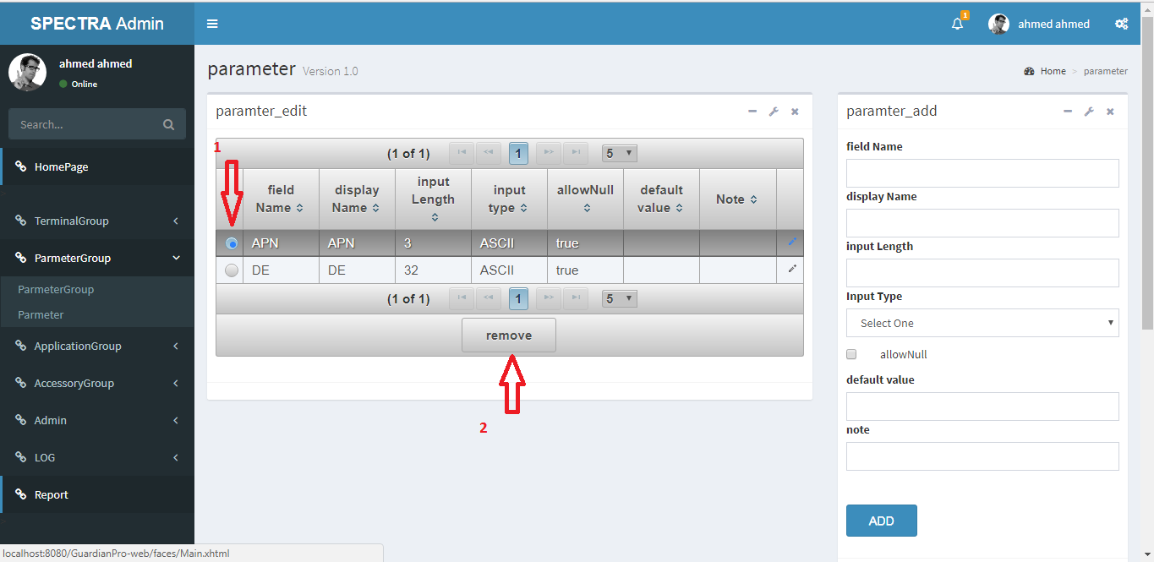

After choose the Parameter, press “remove” button on the bottom to remove.

**Create a new Application Group Record**

To create a new Application Group record, press “ApplicationGroup”

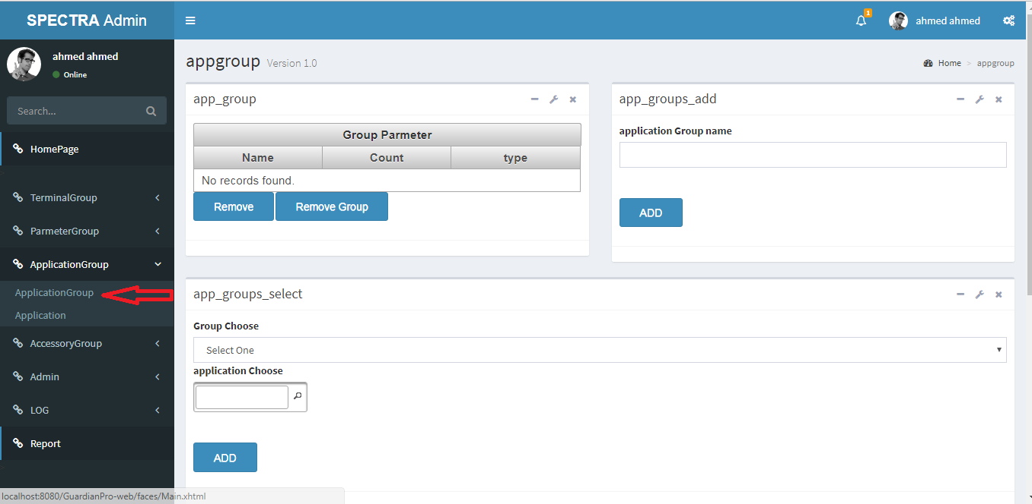

Then the following page will appear:

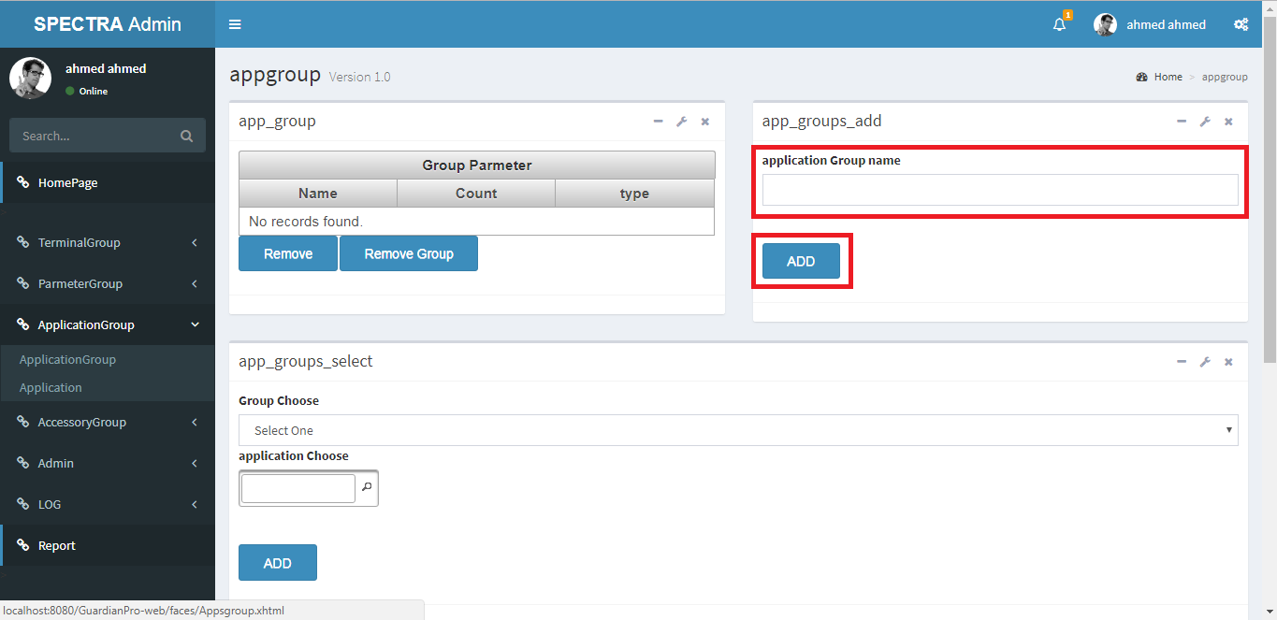

After enter Application Group Name, press “Add” button on the bottom to save.

To attach Application to Application Group.

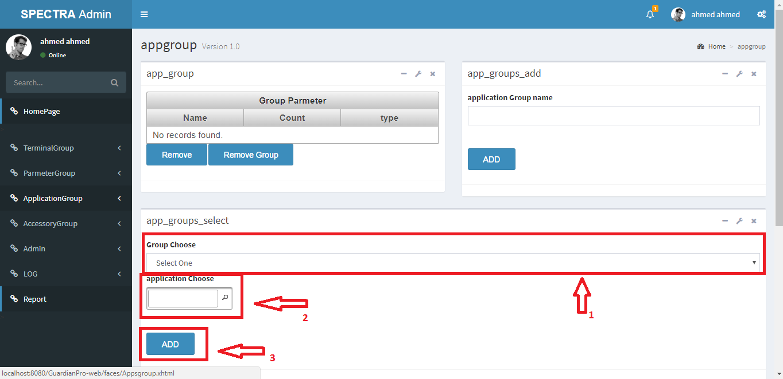

After choose Application Group, attach Application to this group then press “Add” button on the bottom to save.

To remove existing Application Group record.

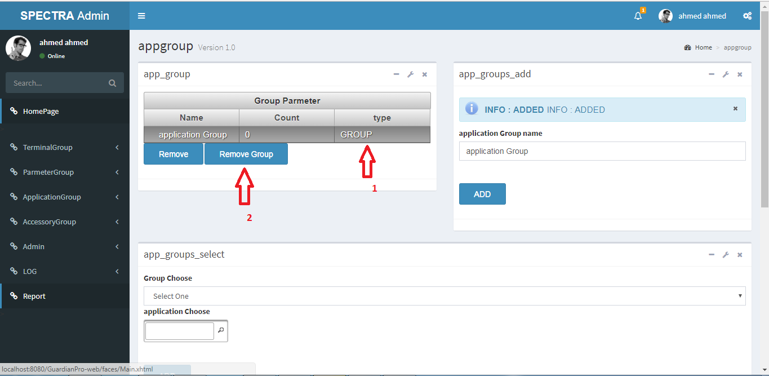

After choose the Application Group, press “remove Group” button on the bottom to remove.

**Create a new Application Record**

To create a new Application record, press “Application”

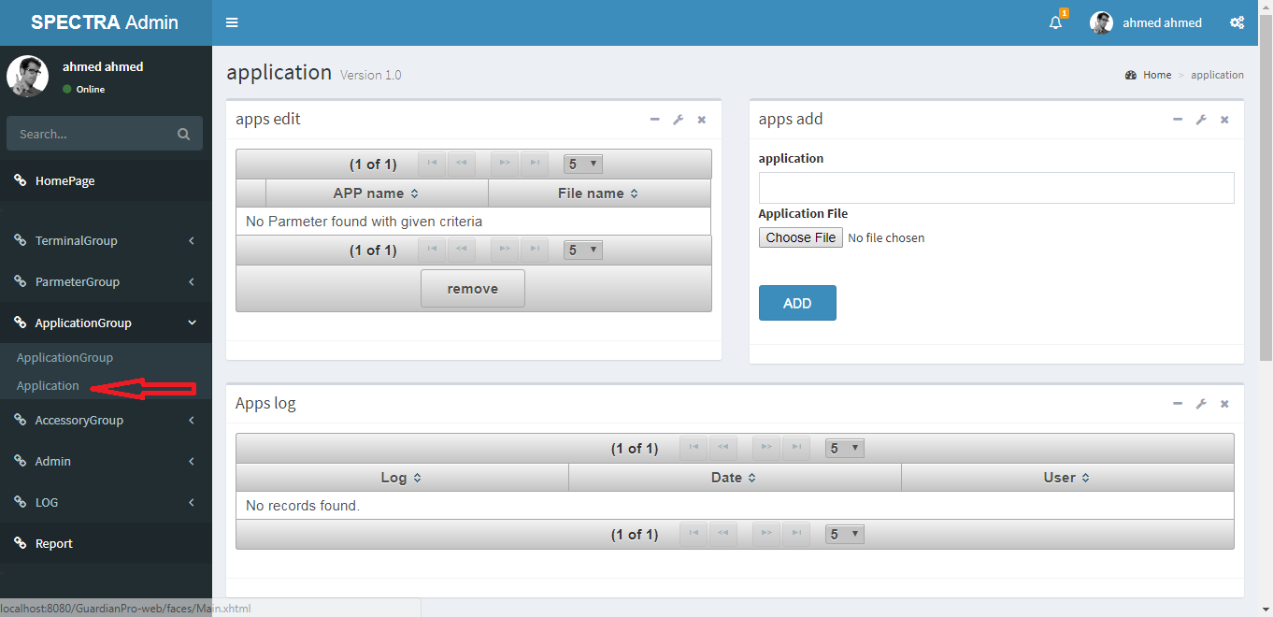

Then the following page will appear:

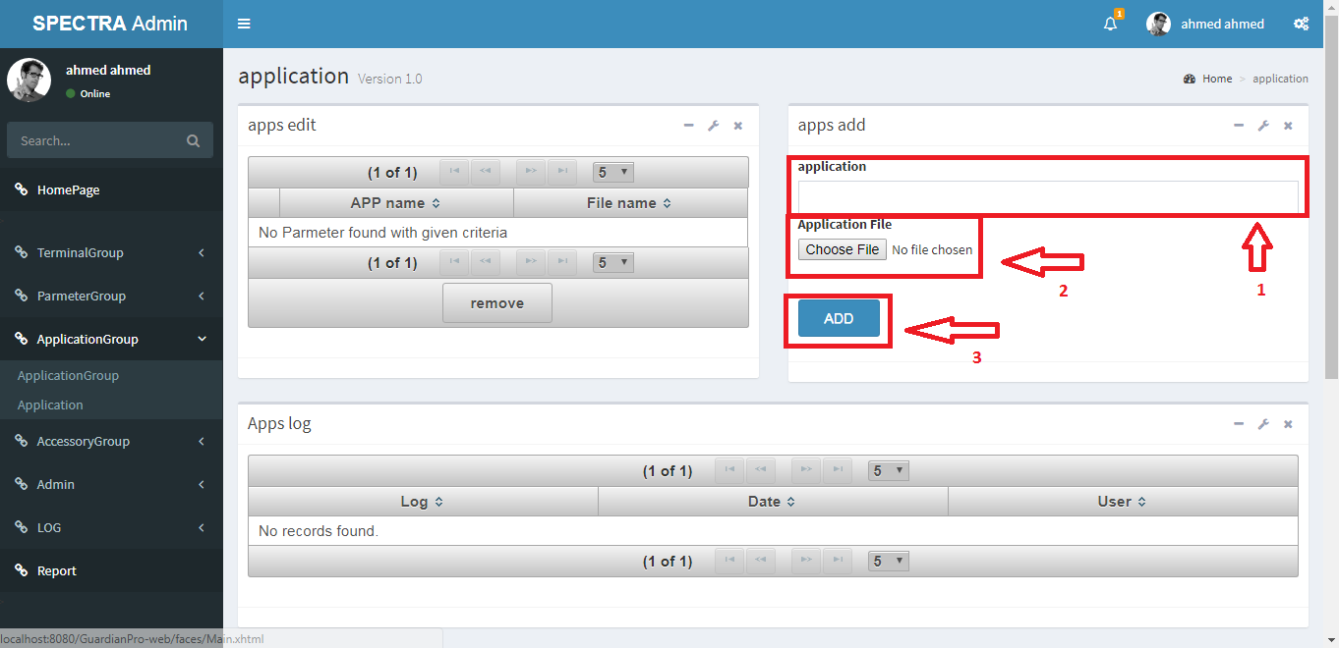

After enter Application Name and choose Application File, press “Add” button on the bottom to save.

To remove existing Application record.

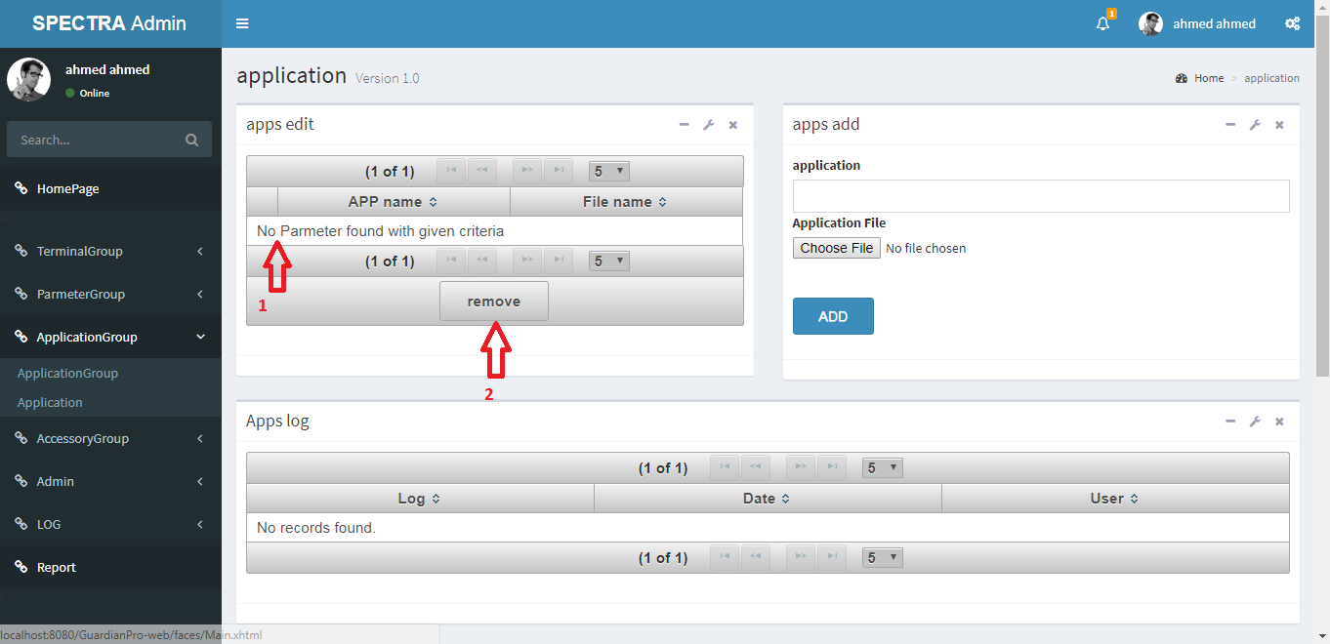

After choose the Application Group, press “remove” button on the bottom to remove.

**Create a new Accessory Group** **Record**

To create a new Accessory Group record, press “AccessoryGroup”

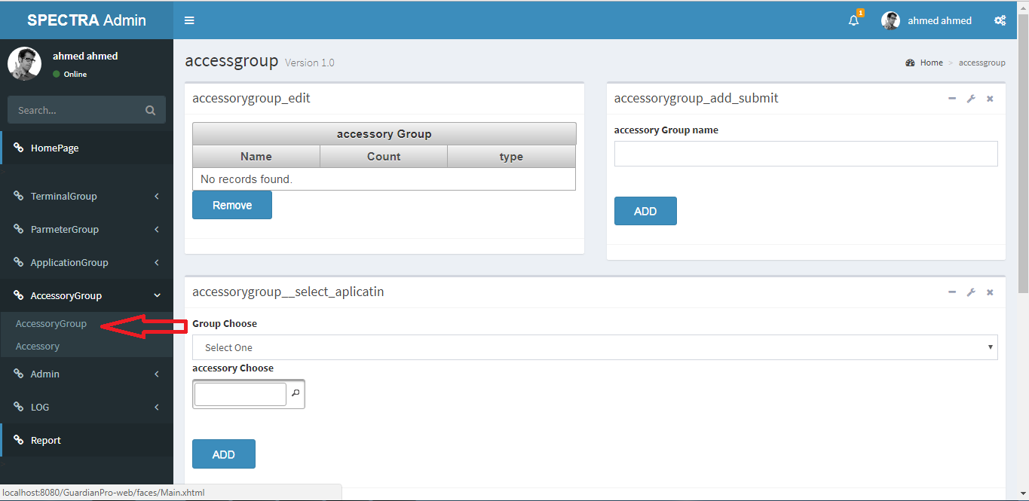

Then the following page will appear:

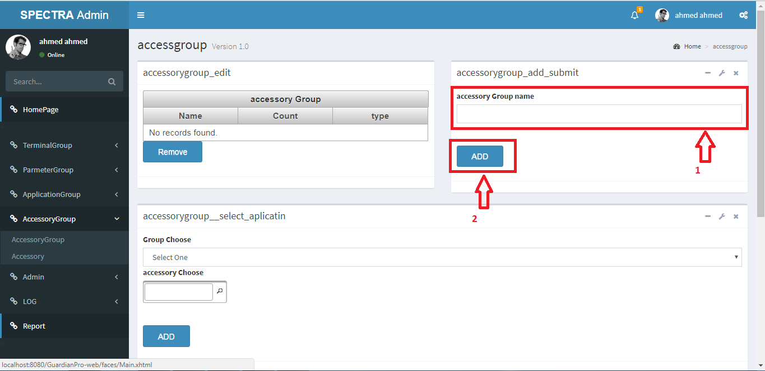

After enter AccessoryGroup Name, press “Add” button on the bottom to save.

To attach Accessoryto AccessoryGroup.

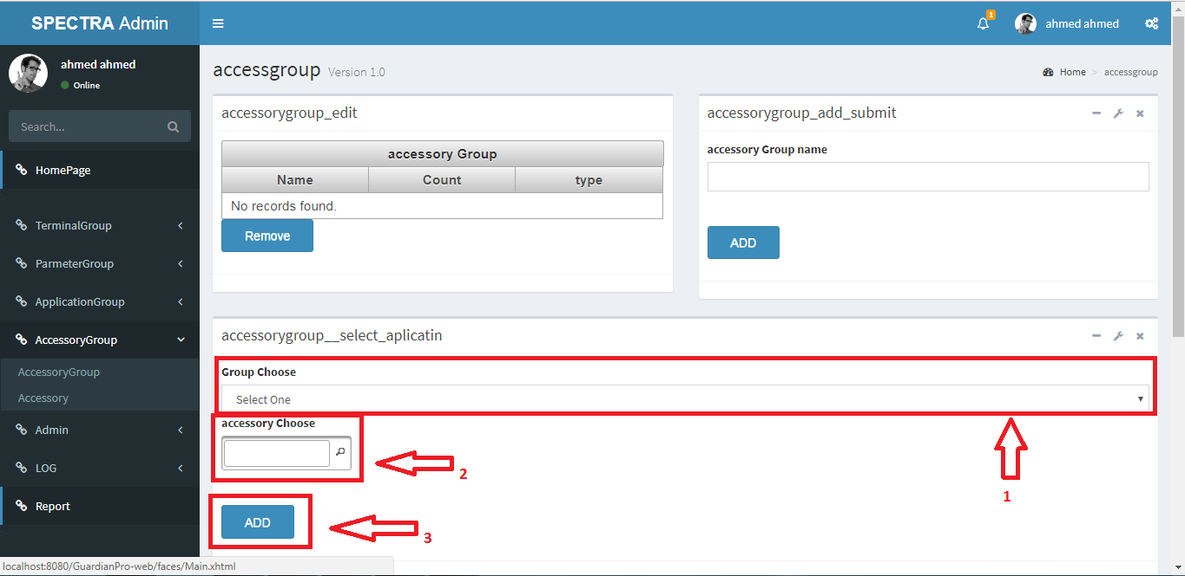

After choose AccessoryGroup, attach Accessoryto this group then press “Add” button on the bottom to save.

To remove existing AccessoryGroup record.

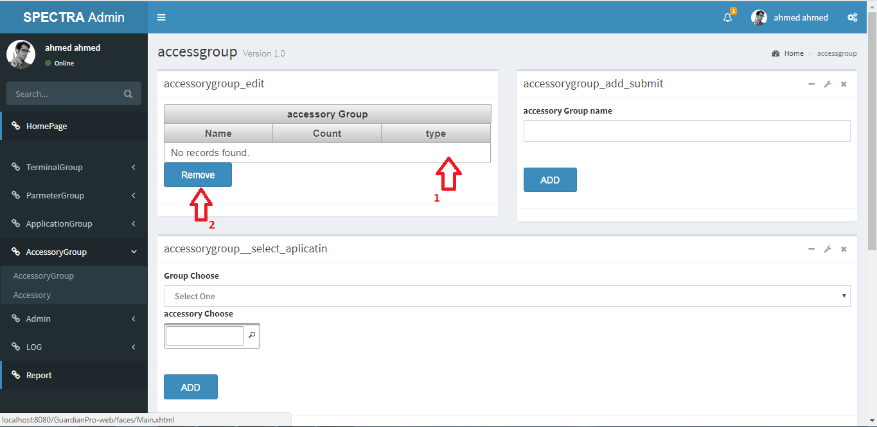

After choose the AccessoryGroup, press “remove” button on the bottom to remove.

**Create a new Accessory Record**

To create a new Accessory record, press “Accessory”

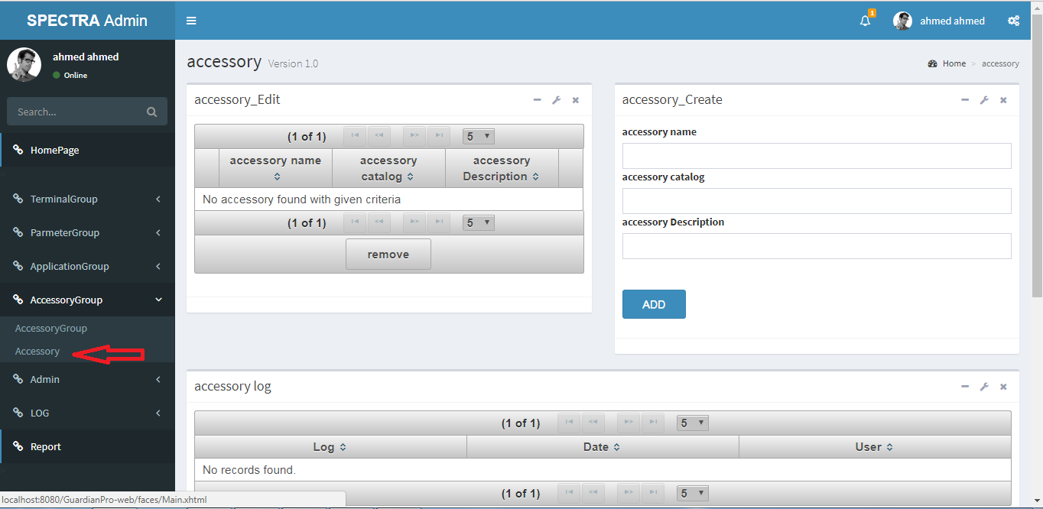

Then the following page will appear:

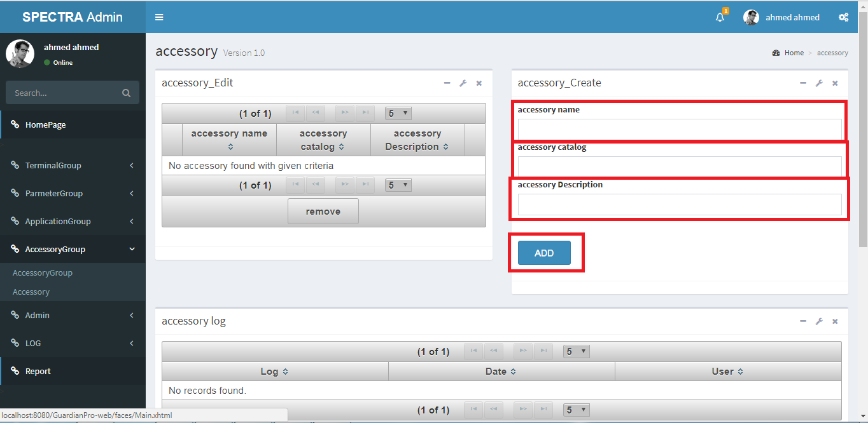

After finish editing all the parameters, press “Add” button on the bottom to save.

To remove existing Accessoryrecord.

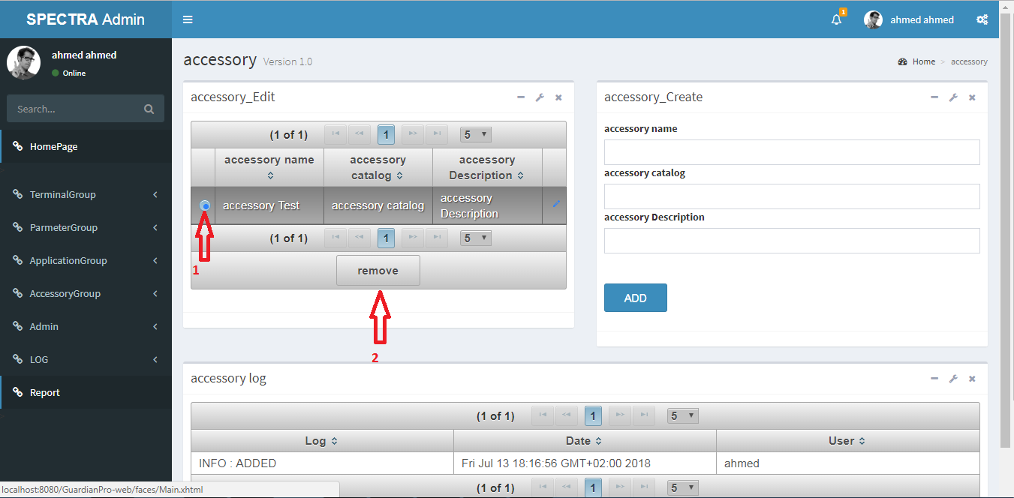

After choose the Accessory, press “remove” button on the bottom to remove.